URS-01 : Admin can login to the website.

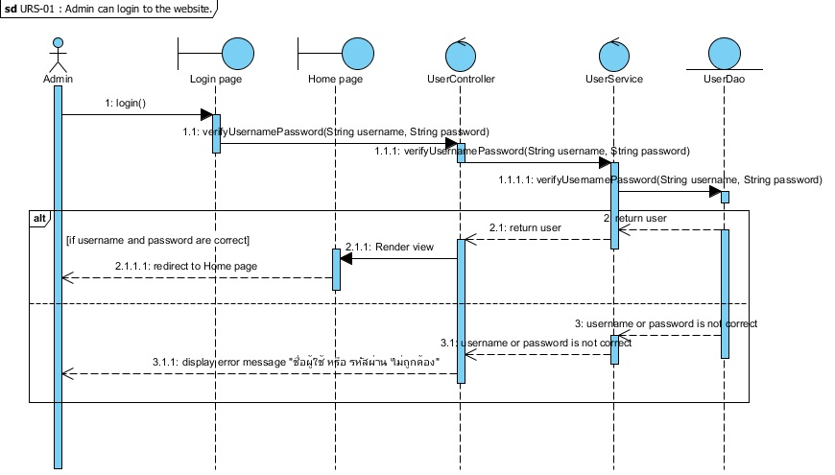Figure 1 : Sequence Diagram of SD-01

The admin can input username and password, which are for admin only to the login page for access to the system. After the system gets username and password,the function login() will verify login account with the database.If the inputs are correct and match with database, the system will redirect to Home page.If the input are wrong, the system will display error message "ชื่อผู้ใช้งาน หรือ รหัสผ่านไม่ถูกต้อง"

URS-02 : Admin can logout to the website.

Figure 2 : Sequence Diagram of SD-02

The admin can logout by click on “ออกจากระบบ” button.Then the system asks the admin to confirm logout. If the admin selects “ตกลง” button, the system will clear admin’s session  in the method and redirect to Login page.

URS-03 : Admin can update temple history.

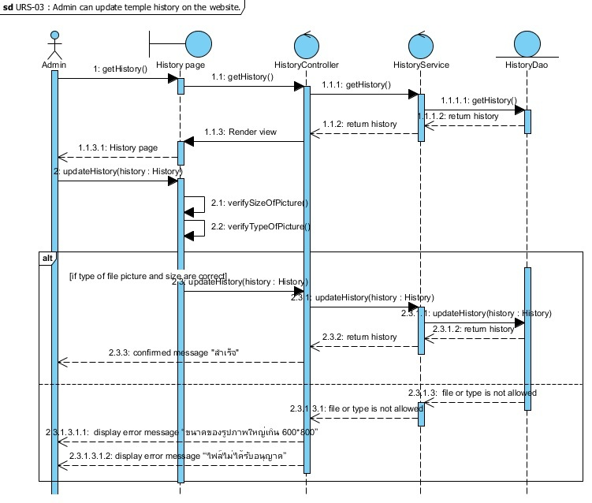

Figure 3 : Sequence Diagram of SD-03

The admin can view existing history that the system gets from the database by using getHistory(). The admin can update temple history by putting pictures then the system will verify type and size of pictures by using verifySizeOfPicture() and verifySizeOfPicture(). If the pictures are correct, the system will add new updated data into the database by using updateHistory() and display the confirmed message “สำเร็จ”. But if the pictures are not correct, the system will display message “ขนาดของรูปภาพใหญ่เกิน 600*800” or “ไฟล์ไม่ได้รับอนุญาต”.

URS-04 : Admin can update contact information on the website.

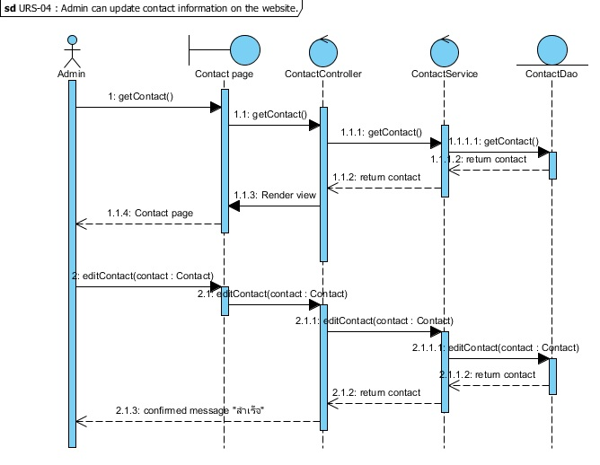

Figure 4 : Sequence Diagram of SD-04

The admin can view existing contact information that the system gets from the database by using getContact(). The admin can change contact information then the system will add new updated data into the database by using editContact() and display the confirmed message “สำเร็จ”.

URS-05 : Admin can update temple news in News page.

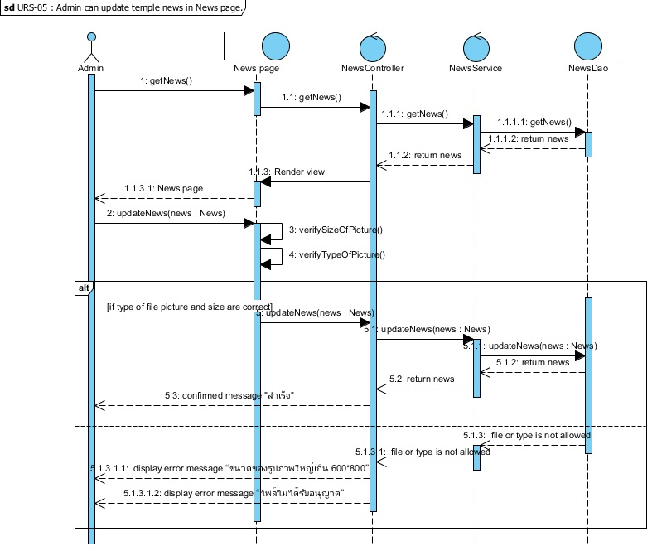

Figure 5 : Sequence Diagram of SD-05

The admin can view existing temple news that the system gets from the database by using getNews(). The admin can update temple news by putting news pictures then the system will verify type and size of pictures by using verifySizeOfPicture() and verifySizeOfPicture(). If type and size of pictures are correct, the system will add new updated data into the database by using updateNews() and display the confirmed message “สำเร็จ”. But if type and size of pictures are not correct, the system will display message “ขนาดของรูปภาพใหญ่เกิน 600*800” or “ไฟล์ไม่ได้รับอนุญาต”.

URS-06 : Admin can view preview News page before saving updated News page into the system. ////

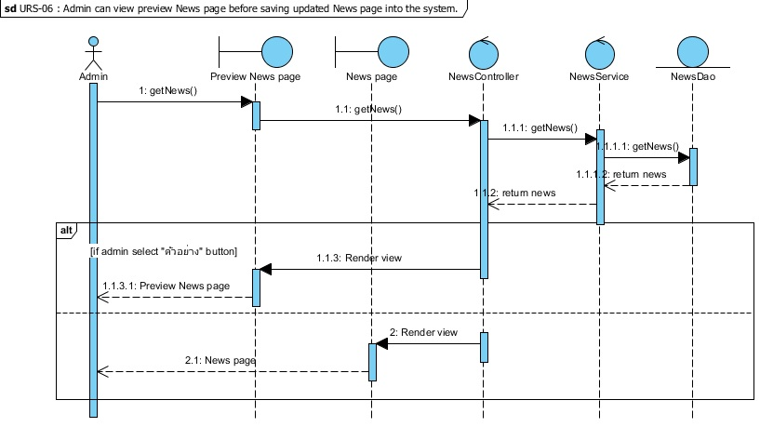

Figure 6 : Sequence Diagram of SD-06

The admin views preview News page before saving updated information by click on “ตัวอย่าง” button then the system will redirect to Preview News page and get news information by getNews(). If the admin clicks on “ยกเลิก” button, the system will redirect to News page.

URS-07 : Admin can view preview Home page before updating Home page into the system.//////

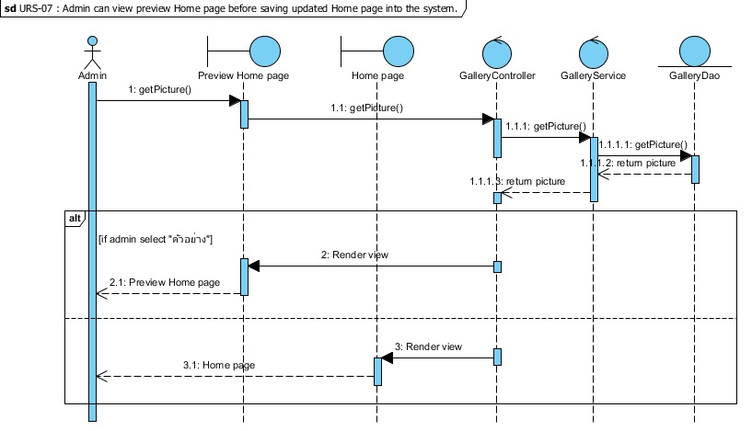

Figure 7 : Sequence Diagram of SD-07

The admin views preview Home page before saving updated information by click on “ตัวอย่าง” button then the system will redirect to Preview Home page and get pictures on the Home page by getPicture(). If the admin clicks on “ยกเลิก” button, the system will redirect to News page.

URS-08 : Admin can update temple pictures on the Home page.

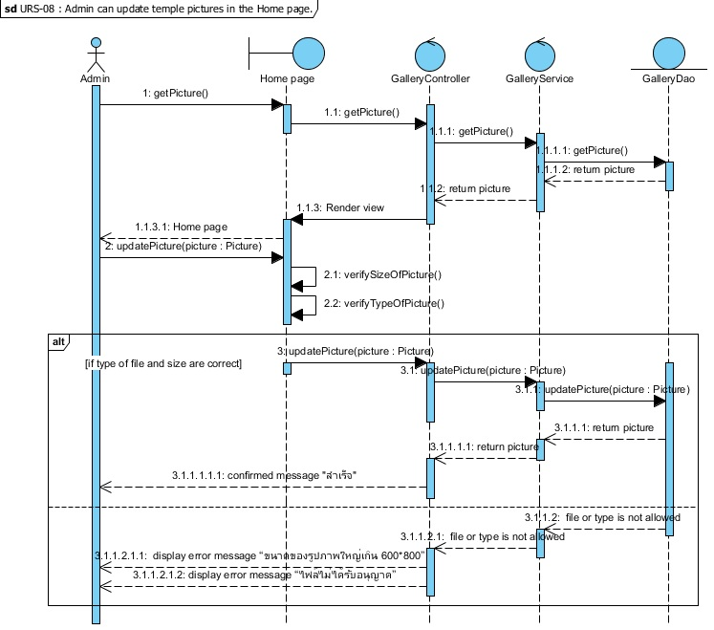

Figure 8 : Sequence Diagram of SD-08

The admin can view existing temple pictures on the Home page that the system gets from the database by using getPicture(). The admin can update temple pictures by putting new  temple pictures then the system will verify type and size of pictures by using verifySizeOfPicture() and verifySizeOfPicture(). If type and size of pictures are correct, the system will add new updated data into the database by using updatePicture() and display the confirmed message “สำเร็จ”. But if type and size of pictures are not correct, the system will display message “ขนาดของรูปภาพใหญ่เกิน 600*800” or “ไฟล์ไม่ได้รับอนุญาต”.

URS-09 : Admin can add new gallery on the Gallery page.

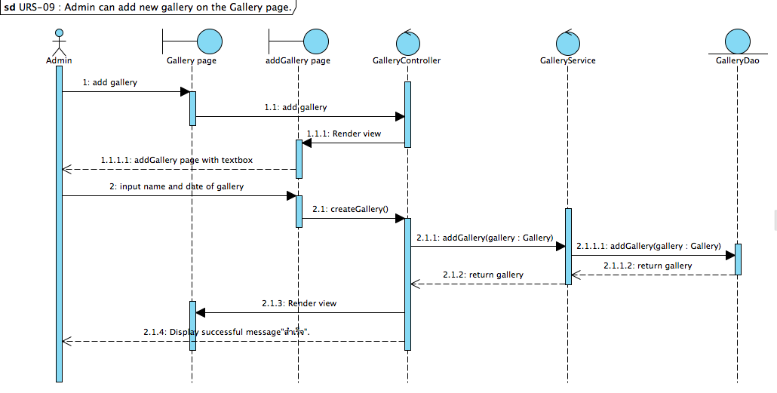

Figure 9 : Sequence Diagram of SD-09

In part of admin management, the admin can add new gallery by click on “เพิ่มอัลบั้ม” button on the Gallery page and input name and date of the gallery. After the system get name and date of gallery, the function createGallery() will add new gallery into the database and display new gallery on the Gallery page to the admin.

URS-10 : Admin can add new pictures in the gallery.

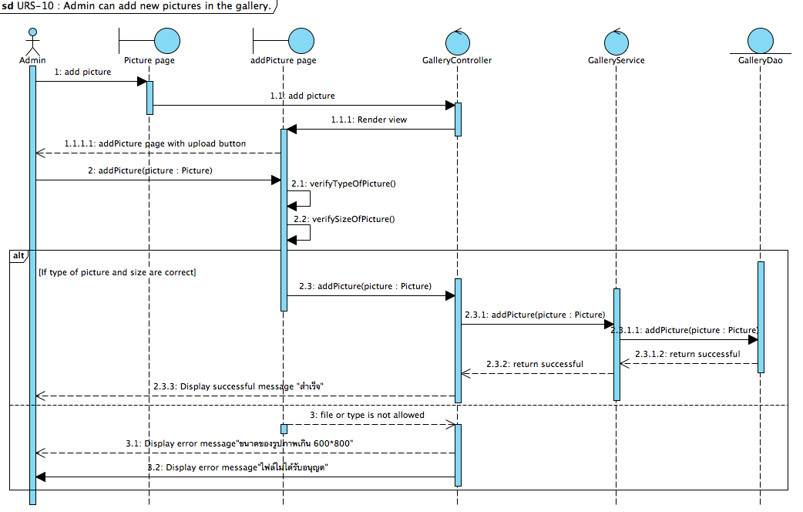

Figure 10 : Sequence Diagram of SD-10

In part of admin management, the admin can add new pictures in the gallery by select one from a list of gallery in the Gallery page and click on “เพิ่มรูปภาพ” button on Picture and upload pictures. After admin completed to upload new picture, the system will check size of picture which are not greater than 600*800 and type of picture must be only jpg. If all pictures is correct the system will add new picture into the database and display “สำเร็จ” message, but if founded some picture is incorrect the system will display error message that are”ขนาดรูปภาะเกิน600*800” or”ไฟล์ของรูปภาพไม่ได้รับอนุญาต”.

URS-11 : Admin can edit details of each gallery.

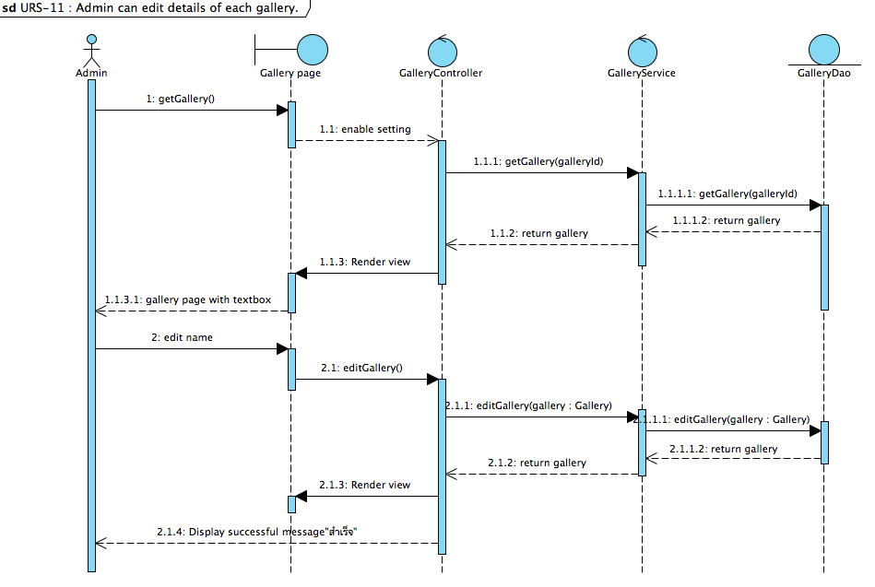

Figure 11 : Sequence Diagram of SD-11

        In the part of admin management, the admin can edit details of each gallery by clik “แก้ไข” on the Picture page. The system will display editPicture page that include with textbox and current information of selected gallery. After the admin input new information of gallery and click on”บันทึก” button, the system will call a function editGallery() to update new information into the database and display  successful message “สำเร็จ”.

URS12- Admin can delete picture in gallery

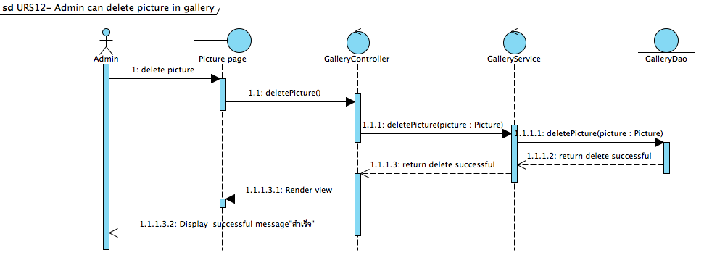

Figure 12 : Sequence Diagram of SD-12

In the part of admin management, the admin can delete pictures in the gallery by click “ลบ” button on the editPicture page. After the admin click “ลบ” button, the system will call a function deletePicture() to delete the selected picture from the database.

URS-13 : Admin can receive questions from the user.

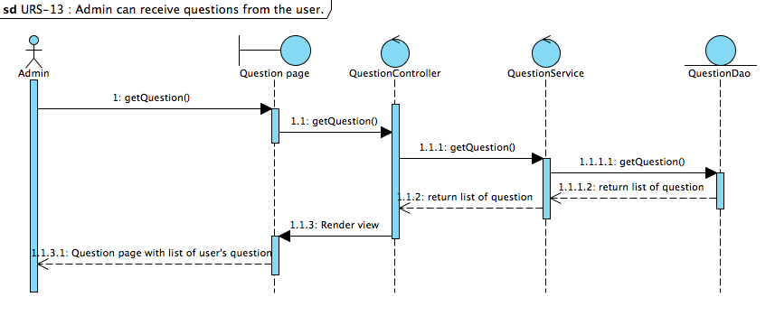

Figure 13 : Sequence Diagram of SD-13

In the part of admin management, the admin can receive questions from the user by click on Question-Answer menu. After the admin access to the Question-Answer menu, the system will call a function getQuestion() to receive the user’s questions from the database and display list of the user’s questions to admin on the Question page.

URS-14 Admin can answer the question.

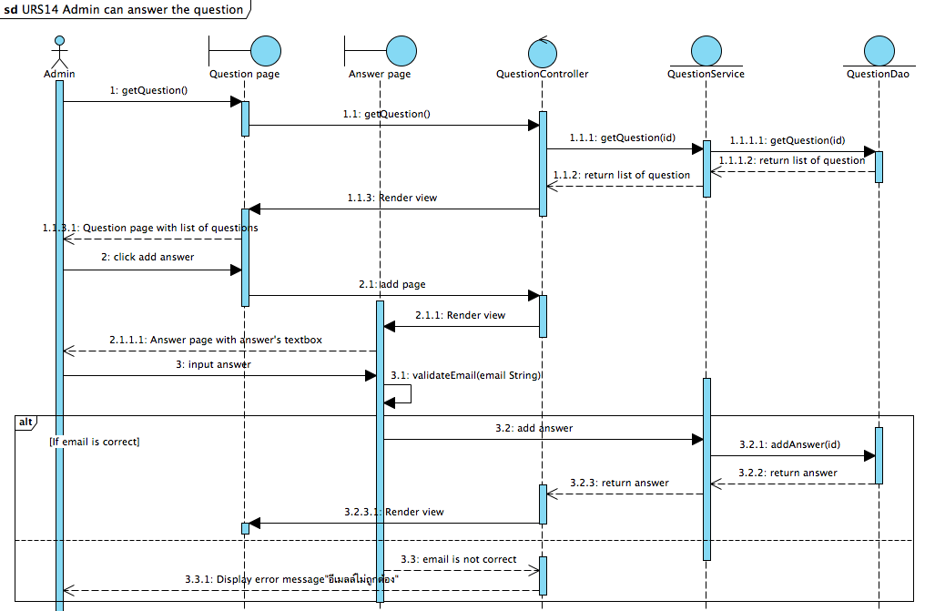

Figure 14 : Sequence Diagram of SD-14

In the part of admin management, the admin can answer the user’s question on the website by click on ”ตอบ” button and then the system will provide Answer page that include with textboxes for admin to input the answer and input the user’s email. After the admin completed to input the answer and the user’s email and click “ส่ง” button, the system will check the email format. If the email’s format is correct, the system will call a function addAnswer() to add the answer into the database. If the email format is not correct, the system will display error message “อีเมลล์ไม่ถูกต้อง” to the admin.

URS-15 : Admin can send news to registered users’ email.

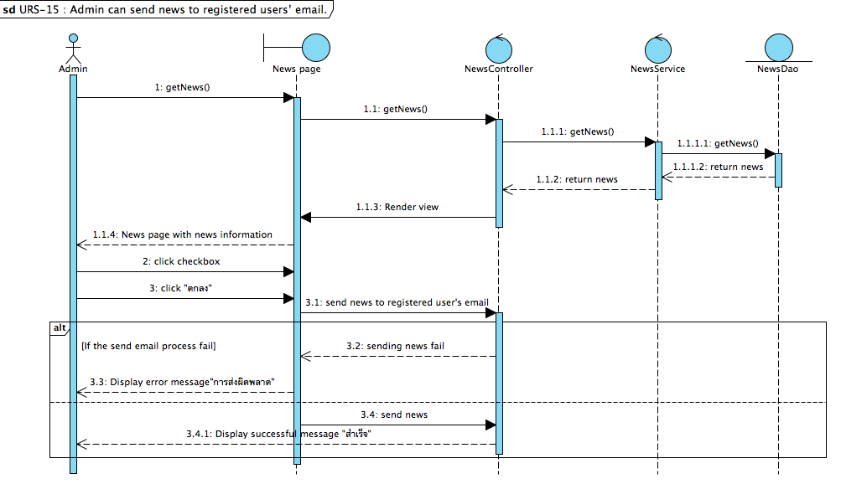

Figure 15: Sequence Diagram of SD-15

In the part of admin management, the admin can send news to registered user’s email by click checkbox on the News page and then the system will display confirm message “คุณยืนยันที่จะส่งข่าวสาร ถึงสมาชิก”. After the admin view list of the registered user’s email and click “ยืนยัน” button, the system will send news information to the user. If the process is fails, the system will show error message “การส่งผิดพลาด”. If the process is pass, the system will send the news to the registered user.

URS-16- Admin can delete the user's question on the website.

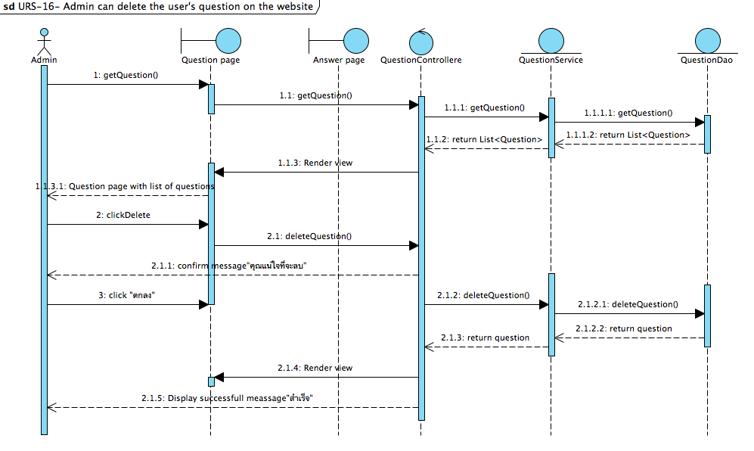

Figure 16 : Sequence Diagram of SD-16

In the part of admin management, the admin can delete the user’s question by click “ลบ” button on the Question page. After the admin click ”ลบ” button, the system will call a function deleteQuestion() to delete the question from the database and display successful message “สำเร็จ”.

URS-21 : User can register to the website

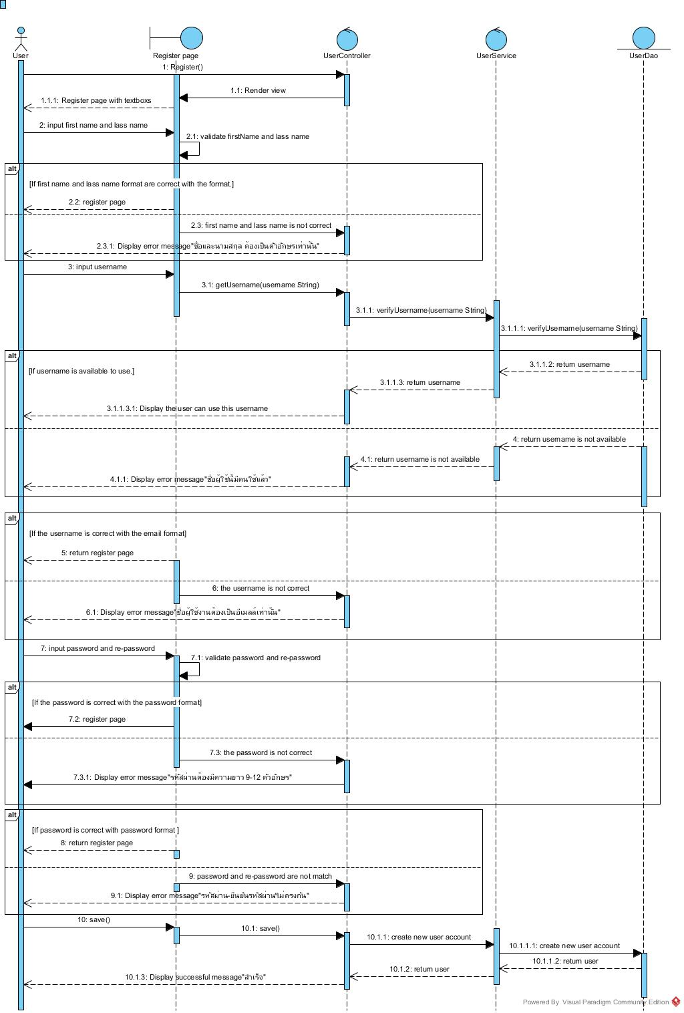

Figure 21 : Sequence Diagram of SD-21

The user can register to the system by click ”ลงทะเบียน” button on an any page and then the system will provide textboxes for receive first name, last name, password and re-password of the user.

After the user completed to input the first name and last name, the system will validate first name and last name format. If the first name and last name format are correct, the system will allow the user to click ”ตกลง” button for register to the system. If the first name and last name are not correct, the system will display error message “ืชื่อและนามสกุล ต้องเป็นตัวอักษรเท่านั้น”.

After the user completed to input the username, the system will verify the username format. If the username format is correct and available for use, the system will allow the user to click ”ตกลง” button for register to the system. If the username is not correct or unavailable for use, the system will display error message “ชื่อผู้ใช้ต้องเป็นอีเมลล์เท่านั้น” or “ชื่อผู้ใช้นี้มีคนใช้แล้ว”.

After the user completed to input the password and re-password, the system will validate password format and re-password. If the password is correct and match with the re-password, the system will allow the user to click ”ตกลง” button for register to the system. If the password is not correct and password is not match with the re-password, the system will display error message “รหัสผ่านต้องมีความยาว9-12ตัวอักษร”or “รหัสผ่านและยืนยันรหัสผ่านไม่ตรงกัน”.

After the user completed to input all information and click”ตกลง” button, the system will call a function save() to create new user account into the database and display successful message “สำเร็จ” to the user.

URS-17 : Registered user can login to the website. //อันนี้ลองไปดูของกู urs01 เหมือนของมึงล่ะนะ

SD-17 : Registered user can login to the website.

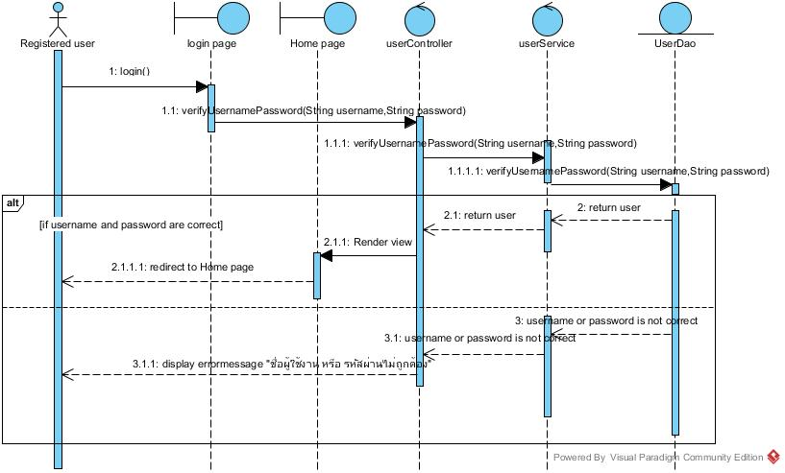

Figure : Sequence Diagram of SD-17

The user can input username and password to the login page for access to the system.

After the system get username and password,the function login() will verify user account with the database.If the inputs are correct and match with database; the system will redirect to Home page.If the input are wrong; the system will display error message "ชื่อผู้ใช้งาน หรือ รหัสผ่านไม่ถูกต้อง"

URS-18 : Registered user can log out to the website. //อันนี้มันต้องมีที่ controller ถามว่า ต้องการจะออกจากระบบใช่มั้ย อะ  แต่กูทำไม่เปน เลยยังไม่ได้ทำ ok

SD-18 : Registered user can log out to the website.

Figure : Sequence Diagram of SD-18

The Registered user can log out to the website. After the system get logout command ,the function logout() will clear session with the controller and the system will redirect to Login page.

URS-19 : Registered user can edit their own registered information. //2. เป็นเหมือนกู  ต้องแก้เปนไป editUser ที่ page ก่อนแล้วค่อยไปเรียกที่ controller เพราะ user เรียก controller ตรงๆไม่ได้ แล้ว 2.1 ไม่ต้องมี render view แล้ว, 2.1.1.1.1.1... เส้นรีเทินเด้อ //แต่ดูของพี่มัน call controller ได้เลยนะ  //อ่าวกำ บอสบอกไม่ได้ ไม่รู้ง้ะ T T ลองถามบอส … บอสบอกเรียกผ่าน view ก่อน v.v ไปแก้ซะอิอิ //อิอิซ่าขี้เกียจจัง //สนน อิอิ

SD-19 : Registered user can edit their own registered information.

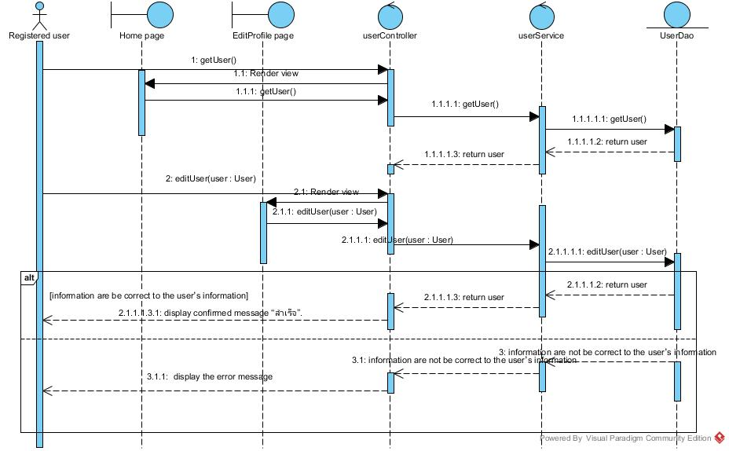

Figure : Sequence Diagram of SD-19

In the part of user management, the user can edit their own registered information.

by click on "แก้ไขข้อมูล" button and the system will call function editUser() to display Userpage that include with field and current user account information,After user complete to input new information to the field and click "ตกลง" button,the system will check validation all fields; if all fields information is correct the system will update information into the database and  display     “สำเร็จ” message,but if founded some field is incorrect the system will display an error message

URS-20 : Registered user can get news from admin by their registered e-mail.

SD-20 : Registered user can get news from admin by their registered e-mail.

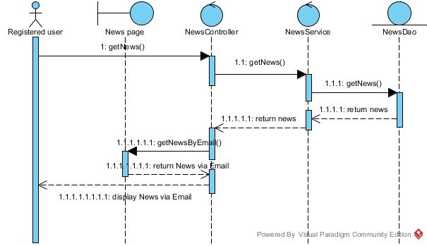

Figure : Sequence Diagram of SD-20

The registered user can get news from admin by their registered e-mail.The system will call function getNews() to get News from database.Then, the system will call getNewsByEmail() to send news to list of members’ email.

URS-22 : User can view temple pictures on the Home page.

SD-22 : User can view temple pictures on the Home page.

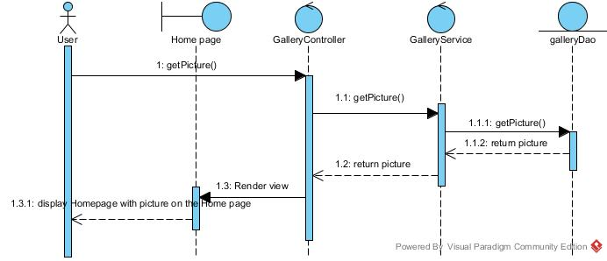

Figure : Sequence Diagram of SD-22

The user can view temple pictures on the Home page.The system will call getPicture() to display temple pictures on the Home page.

URS-23 : User can view temple news

SD-23 : User can view temple news

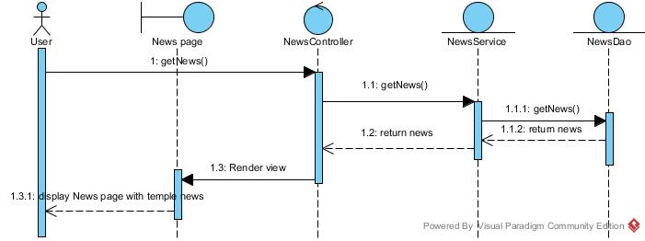

Figure : Sequence Diagram of SD-23

The user can view temple news.The system will call getNews() of News Controller, and News Controller will call getNews() to get news from the database to display temple news.

URS-24 : User can view the temple history.

SD-24 : User can view the temple history.

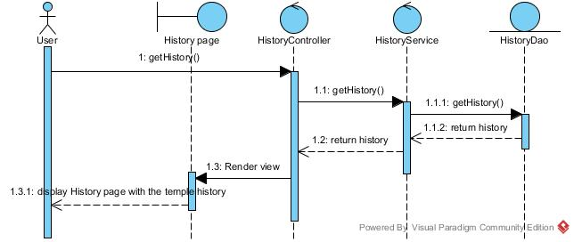

Figure : Sequence Diagram of SD-24

The user can view temple news.The system will call getHistory() of History Controller, and History Controller will call getHistory() of History Service to get the temple history from the database to display the temple history.

URS-25 : User can select gallery. //1.3.1 อยากให้ใช้คำประมานว่า return Gallery page with galleries  ไรประมานนี้  urs อื่นๆด้วยนะ  เพราะถ้าเข้าใจไม่ผิด ถ้าไป render view แล้วให้ page return ออกมา  pageมันจะ return เป็น pageๆ //ok

มีคำถามล่ะ user มันจะไป select ยังไงอ่ะ -.- พอมันดิสเพลมาเป็นแกลลอรี่ทั้งหมด user select อีกทีงี้หรอ ล่ะก็call getGallery ใหม่ ? HELP ME Please ? ถ้าเข้าใจกันเอง แบบนี้ก้ถือว่าเข้าใจละนะ สำหรับกู55

SD-25 : User can select gallery.

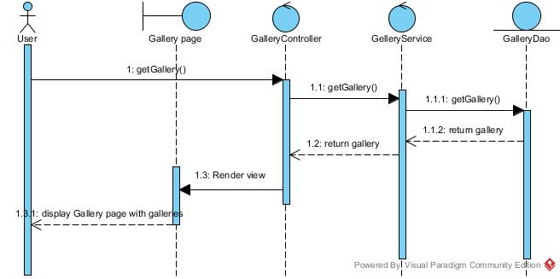

Figure : Sequence Diagram of SD-25

URS-26 : User can view the gallery information of the selected gallery.

SD-26 : User can view the gallery information of the selected gallery.

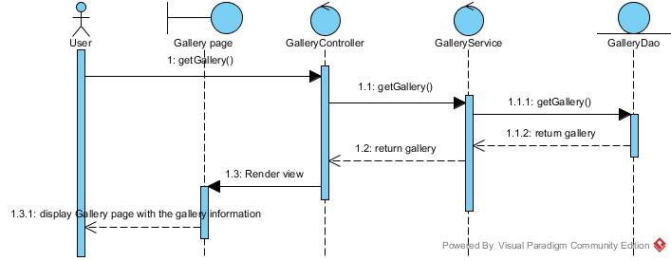

Figure : Sequence Diagram of SD-26

The user can  the gallery information of the selected gallery..The system will call getGallery() of Gallery Controller, and Gallery Controller will call getGallery() of Gallery Service to get the gallery information of the selected gallery from the database to display the gallery information of the selected gallery.

SD-27 : User can view pictures in the selected gallery.

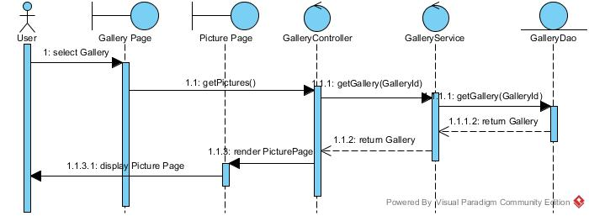

Figure : Sequence Diagram of SD-27

The user can view picture in the selected gallery.The system will call getPictures() of gallery controller, and Gallery Controller will call getGallery(GalleryId) of Gallery Service to get Gallery by of the selected gallery from the database to display pictures of the selected gallery.

SD-28 : User can select picture to view a big picture.

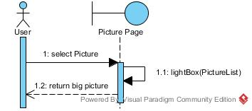

Figure : Sequence Diagram of SD-28

The user can select picture to view a big picture.The system will call listBox(PictureList) and then the system will display big picture.

SD-29 : User can view others users’ question-answer in the Question-Answer page.

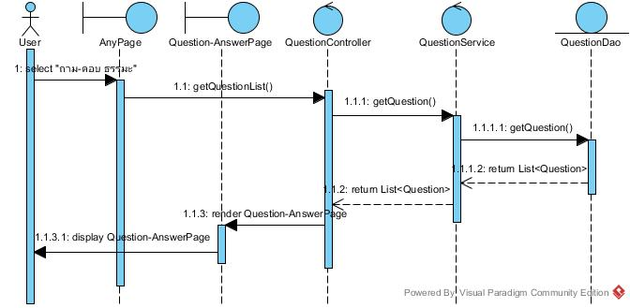

Figure : Sequence Diagram of SD-29

The user can view others users’ question-answer in the Question-Answer page.The system will call listBox(PictureList) and then the system will display big picture.

SD-30 : User can post questions on the Question-Answer page.

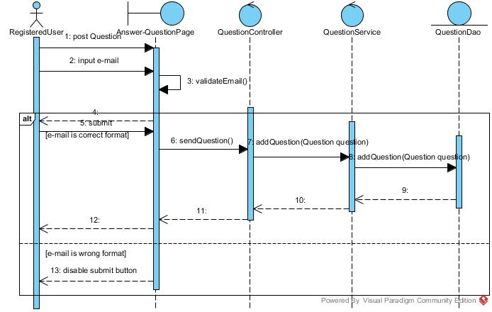

Figure : Sequence Diagram of SD-30

The User can post questions on the Question-Answer page.The user input question and input e-mail then click submit in first step system will call sendQuestion() and send question information to the question service .After that question service will add question to database .

SD-31 : User can receive the answer from admin.

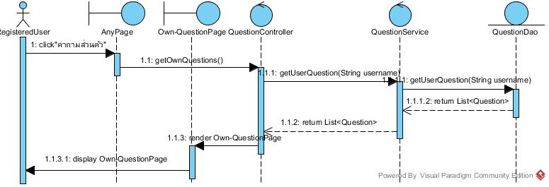

Figure : Sequence Diagram of SD-31

The user can receive the answer from admin.  .The system will call getOwnquestion() of question controller, and Question Controller will call getUserQuestion(String username) of question service to get List<Question> and then return to own question page and render it to display to the user.

SD-32 : User can view temple location on Map page.

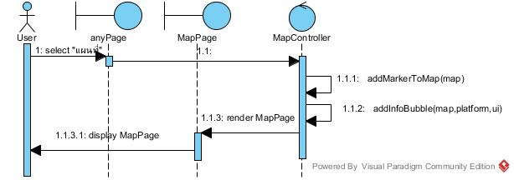

Figure : Sequence Diagram of SD-32

The user can view picture in the selected gallery.The system will call addMarkerToMap(map) for add track temple to map and call addInfoBubble for input temple info bubble to map and then display to the user

SD-33 : User can view the temple contact information.

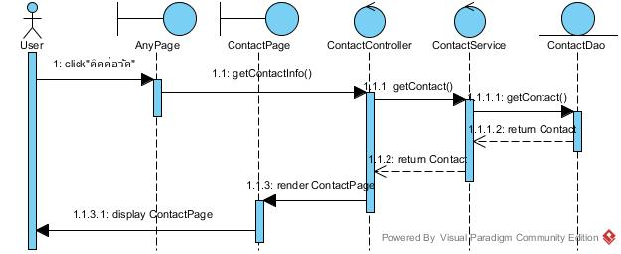

Figure : Sequence Diagram of SD-33

The user can view the temple contact information.The system will call getContactInfo() of Contact Controller, and Contact Controller will call getContact() of Contact Service to get Contact from the database to display contact page.

SD-34 : User can contact temple by using email address.

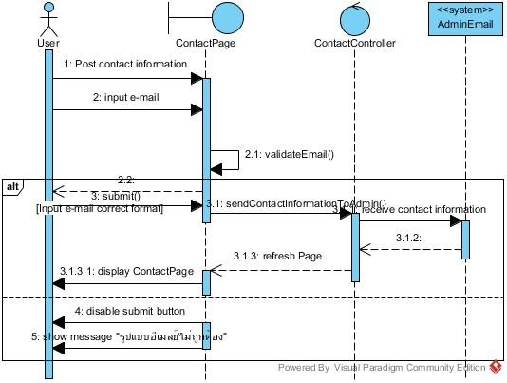

Figure : Sequence Diagram of SD-34

The user can contact temple by using email address.The user input contact information and input e-mail then click submit in first step system will call sendContactInformationToAdmin() and send contact information to the admin email .After that contact page will refresh page.

SD-35 : User can click link on website to like the Facebook page of the temple.

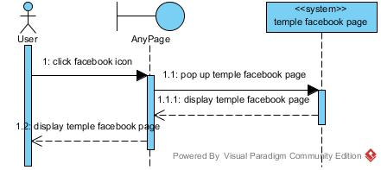

Figure : Sequence Diagram of SD-35

The user can click link on website to like the Facebook page of the temple.The system will pop up temple facebook page after the user click on facebook icon in the menu bar.